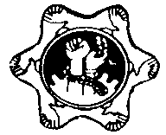

rKu;j;jptq;fpr;rq;f/kfhrq;fq;fspd; guPl;irkPjpapidrkg;gLj;Jjy;.

tq;fpepjpeltbf;ifkw;Wk; kfhrq;fg;gpuptpdhy; ntspaplg;gLk; newpg;gLj;jy; MNyhridg;gj;jpu ,yf;fk; 12,w;fhdxd;gjhtJgpw;Nru;f;if.

- jiytu; fl;Lg;ghl;L rig
rKu;j;jptq;fpr;rq;fk;..................................

- Kfhikahsu;
rKu;j;jptq;fpr;rq;fk;...................................

- jiytu;
epiwNtw;Wf;FO
rKu;j;jpkfhrq;fk; ...................................

- Kfhikg;gzpg;ghsu;
rKu;j;jpkfhrq;fk; ....................................

- jiyikafKfhikahsu;
gpuNjrnrayfk;...........................................

- gpuNjrnrayhsu;/ gpujprKu;j;jpgzpg;ghsu;
gpuNjrnrayfk;............................................

- rKu;j;jpcjtpMizahsu; / khtl;lrKu;j;jpgpujpg; gzpg;ghsu;
khtl;lr; nrayfk;.........................................

- khtl;lxUq;fpizg;Gcj;jpNahfj;jh;
khtl;lr; nrayfk; .........................................

- khtl;lnrayhsu;/ khtl;lrKu;j;jp; gzpg;ghsu;
khtl;lr; nrayfk; .......................................

- gpujhdcs;sffzf;fha;thsu;
,yq;ifrKu;j;jpmjpfhurig

- nghJKfhikahsu; kw;Wk; rfygzpg;ghsu;fs;
,yq;ifrKu;j;jpmjpfhu rig

- nrayhsu;
nghUshjhumgptpUj;jpmikr;R
5Mk; khb, ,y 464,b.gP [ahkhtj;ij
nfhOk;G -10

tq;fpepjpeltbf;ifg; gpupT, ,yq;ifrKu;j;jpmjpfhurig,4Mk; khbnrj;rphpgha>gj;juKy;iy.
2013.08.08

njhiyNgrp ,y :- 0112 873798
njhiyefy; ,y :- 0112 869494

2013.08.08
rKu;j;jptq;fpr;rq;f/kfhrq;fq;fspd;guPl;irkPjpapidrkg;gLj;Jjy;.

tq;fpepjpeltbf;ifkw;Wk; kfhrq;fg;gpuptpdhy; ntspaplg;gLk; newpg;gLj;jy; MNyhridg;gj;jpu ,yf;fk; 12,w;fhdxd;gjhtJgpw;Nru;f;if.

- rKu;j;jptq;fpr;rq;f/kfhrq;fq;fspd;guPl;irkPjpfs;rkg;glhjfhuzq;fspdhy; Vw;gl;lgpur;rpidfSf;FhpaepiyikapidjPu;f;Fk; nghUl;Lnewpg;gLj;jy;MNyhridgj;jpu,yf;fk; 28 kw;Wk; mjpy; Nkw;nfhs;sg;gl;lgpw;Nru;f;iffs; %yk; ntspaplg;gl;ld.

  - cupanewpg;gLj;jy; MNyhridfSf;fikamjpfkhdtq;fp/kfhrq;fq;fs; Kiwaw;wtpjj;jpy; ,Ue;jguPl;irkPjpapidrkg;gLj;Jk;eltbf;iffs;Nkw;nfhs;sg;gl;lJld; xUrpytq;fp/kfhrq;fq;fs; njhlu;e;Jk; mjidmt;thNwnra;Jnfhz;LtUfpd;wJ.

  - mtw;wpilNagyjug;gl;lKiwNfLfs; my;yJ ,aw;ifmopTfs; Nghd;wfhuzq;fspdhy; Vw;gl;lMtzq;fs; njhiye;JNghdikmy;yJxOf;fhw;Weltbf;iffs; fhuzkhfFwpj;jguPl;irkPjpapidrkg;gLj;jKbahky; NghdrKh;j;jptq;fp/kfhrq;fq;fSk; ,jDs; fhzg;gLfpd;wd.

- Nkw;$wg;gl;lrfyepiyikfisAk; fUj;jpy; nfhz;L2000Mk; Mz;Lnjhlf;fk; mjw;FKd;Ds;stUlq;fspd; tq;fp/kfhrq;fq;fspd; guPl;irkPjpapidrkg;gLj;Jk; gzpapy; KOikahf<Lgl;bUe;jgzpahsh;fSf;FtUl ,Wjp ,yhggfph;tpd; NghJfPo; fhzg;gLk; tifapy; Cf;Ftpg;GnfhLg;gdnthd;iwtoq;fjPu;khdpf;fg;gl;Ls;sJ.

  - ,yhggfph;jypd; nghUl;LVw;fdNtntspaplg;gl;Ls;snewpg;gLj;jy;MNyhridg;gj;jpu ,yf;fk; 12,w;fhd7Mk; 8Mk;gpw;Nru;f;iffspd; gbgzpahsh;fSf;fhf 5% tPjk;xJf;fg;gl;Ls;sJ.

  - mjw;fikatq;fp/kfhrq;fq;fspy; Kd;du; flikahw;wpacj;jpNahfj;ju;fSf;FCf;Ftpg;Gf; nfhLg;gdTvd;wtifapy; cupj;jhd E}w;WtPjj;jpy; 50%j;jpidFwpj;jguPl;irkPjpapidrkg;gLj;Jk; gzpapy;<Lgl;Ls;sjw;Nghijagzpahsh;fSf;Ftoq;f ,jd; %yk; mDkjpiatoq;Ffpd;Nwhk;.

  - fscj;jpNahfj;ju;fSf;F ,J chpj;Jilajhfhtpl;lhYk;;>guPl;irkPjpapidrkg;gLj;jpf; nfhs;Sk;gzpf;fhffseltbf;iffSf;FNkyjpfkhfxUcj;jpNahfj;jiu ,f;flikapyd; nghUl;LKONeuNtiyapy; <LgLj;jpf; nfhz;lhy; NkNy ,yf;fk; 2.2 ,d;gpufhuk;cs;s 50% tPjj;ijxd;NwhLxd;WNru;j;JFwpj;jjw;Nghijagzpahsu;fSf;Frkkhfg;gq;fplg;gly;Ntz;Lk;.(fscj;jpNahfj;jUf;Fk; fpilf;Fk; tifapy;)

- ,t;thWjw;Nghijagzpahsh;fSf;FNkyjpfkhdCf;Ftpg;Gf; nfhLg;gdthd 50% j;jpidtoq;Fifapy; Fwpj;jcj;jpNahfj;ju; fzf;fha;TMz;bw;Fs; KONeuguPl;irkPjpapidrkg;gLj;Jk; gzpapy; <Lgl;bUe;jhu; vdKfhikahsu; jpUg;jpg;gly;Ntz;Lk;.

  - Kd;dh; ,Ue;jcj;jpNahfj;ju;fSf;Fcupj;jhdCf;Ftpg;Gf; nfhLg;gdthd50%j;jpidFwpj;jguPl;irkPjpapidrkg;gLj;jpagzpahsh;fSf;FnrYj;jpagpd; kPjpahf ,Uf;Fk; 50%tPjj;ijgzpahsu; Cf;Ftpg;GnfhLg;gdTf; fzf;fpy; gpbg;gzkhfitj;jy;Ntz;Lk;.

  - ,it njhlu;ghdfzf;Fg; gjpTfs;rPuhf;fg;gl;ljd;gpd;du; me;je;jtUlq;fspy; gpbgzkhfitf;fg;gl;l 50%tPjj;jpidgzpahsh; Cf;Ftpg;GnfhLg;gdTj; njhifapidjdpahfg; NgNuLxd;wpy; gpd;dh; ghh;j;Jf; nfhs;Sk; nghUl;Lgjpe;Jitj;jy;Ntz;Lk;.

  - rKu;j;jpmjpfhurigapd; tq;fpepjpeltbf;ifg;gpupTjPu;khdk; xd;iwvjpu;fhyj;jpy; toq;Fk; tiuKd;dh; ,Ue;jgzpahsh;fSf;FCf;Ftpg;GnfhLg;gdtpidtoq;ff; $lhJ.

- me;je;jtUlq;fSf;FupaguPl;irkPjprkg;gLj;jiyme;je;jtUlj;jpw;Fs; Nkw;nfhs;shJmLj;JtUk; tUlk; xd;wpy; mg;gzpahsh;fNsguPl;irkPjpapidrkg;gLj;Jk; eltbf;iffisnra;jpUe;jhy; mtu;fSf;Fk;Cf;Ftpg;GnfhLg;gdTfpilf;fNtz;baJld;NkNyge;jp 2.2 ,d; gbahFk;.

- tq;fpr;rq;fj;jpy; Nritahw;wpa/Nritahw;Wk; gzpahsh;fSf;Fkl;Lk; Nkw;Fwpg;gplg;gl;Ls;sthWCf;Ftpg;Gf; nfhLg;gdTg; gfpu;Tcupj;jhtJld; fscj;jpNahfj;ju;fSf;Fme;je;jtUlq;fismbg;gilahff; nfhz;LKd;du; ,Ue;jCf;Ftpg;GtPjj;ijNatoq;Fjy;Ntz;Lk;.

- ,yhgg;gfph;Tnjhlu;gpy; ,jw;FKd;du; ntspaplg;gl;lMNyhridfs; njhlu;e;Jk; khw;wq;fspd;wpeilKiwapypUf;Fk;.

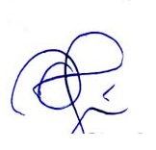
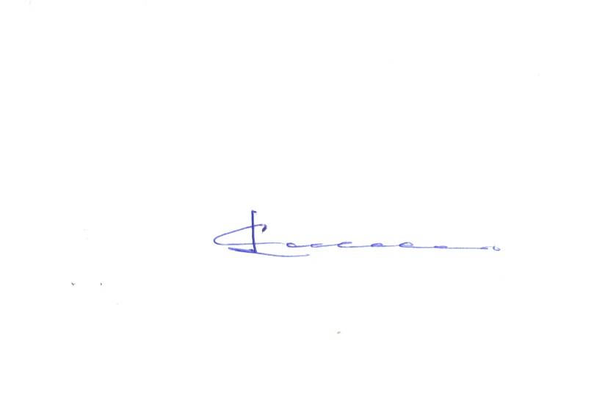

Mu;.gp.gP.jpyfrpup Nf.Nf.vy; re;jpujpyf;f
gzpg;ghsu; ehafk;. gpujp–gzpg;ghsu; tq;fpepjp
eltbf;ifkw;Wk; kfhrq;fk;

